**Assignment 6: WebSim**

**1. Write a simple Alpha Expression (example Rank(-Delta(close,3))) and simulate the expression under each of the following scenarios –**

**a. Universe Choice – TOP3000, TOP100**

**b. Delay – 0,1**

**c. Neutralization – None, Market**

**d. Max Stock Weight- 0.1,0.5**

**This would lead to a total of 16 runs to cover all the combinations.**

Table 1 shows the 16 simulation combinations of Rank(-Delta(close,3)) inputted into the Alpha Expression on WebSim.

**Table 1: WebSim Simulations**

**3. Compare and Contrast the Stats of each of these runs.  Which simulations worked best - give your views as to why.**

A good Alpha would have consistently increasing profit and losss (PnL) and high Annual Return, Sharpe Ratio, % Profitable Days and Profit per Dollar Traded. The alpha should also have low Drawdown and Turnover. And more importantly, it should not have high fluctuations in the cumulative profit graph. If the standard deviation is low, there would be lesser fluctuations in the graph. If the graph shows high fluctuations/volatility, despite the returns being high, the Alpha will not be deemed good enough. An Alpha is considered to be “good” if:

* Its turnover is less, but never less than 1%
* Its Percentage Drawdown should be less than 10%
* Sharpe should be greater than 1.95 for delay 0 Alphas and around 1.5 for delay 1 Alphas.

The measures can also be easily interpreted using the fitness value. The Fitness, which is defined in the Alpha Performance help page, as

Fitness = Sharpe * sqrt(abs(Returns) / Turnover);

Table 2 show the alpha performance fitness recommendations.

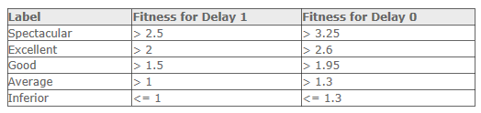

**Top3000 Simulation results (Figure 1)**

For Top3000, Sim5, Sim6 and Sim7 worked best with an average performance fitness of 1.26 (>1). Since, the simulations were from for Delay 1, having fitness greater than 1 gives them an average performance. The rest of the simulations had inferior performance. The simulations show that Delay 1 simulations worked best, which is implies that a conservative trading strategy (D1) produced better results compared to an aggressive trading strategy (D0). Therefore, the best position was achieved when we used a lag of 1 day. However, there was no significant difference between the Max Stock (or Contract) Weight of 0.1 and 0.5. Therefore, the maximum weight for each stock (or contract) in the overall portfolio did not affect the trading strategy among the best simulations. The results also show a minor difference between the simulations with market neutralization (Sim6) and those without (Sim5 & Sim7). The market neutral alpha (Sim6) had the returns (32.13%) and a PnL of 15.8 Million. However, the simulations had high turnover, high percentage drawdown (>10%) and the simulations were predominantly long position strategies with no short positions. Therefore, opportunities to improve the simulation may come from more including short positions, reducing the percentage drawdowns. The summary of the Sharpe and PnL measures for the Top3000 simulations are presented in Figure 1 below.

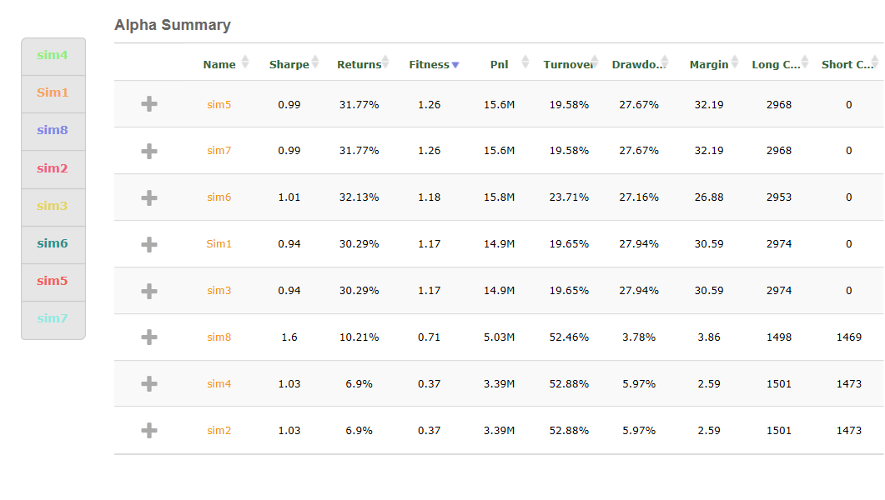

Figure 1: Top3000 Simulation Runs

**Top200 Simulation results (Figure 2)**

For Top200, Sim15, Sim13 worked best with an average performance fitness of 1.14 (>1). The simulations were also from for Delay 1. Similarly, there was no significant difference between the Max Stock (or Contract) Weight of 0.1 and 0.5. The Top200 like the Top3000 had high turnover, high percentage drawdown (>10%) and the best simulation runs were predominantly long position strategies with no short positions. The results suggest that the Universe with more stock options (Top3000) brings in better returns and fitness compared to the smaller Top200 portfolio. Overall, the results show that increasing the short positions, will result in a higher turnover and reduce the percentage drawdowns. Therefore, an optimum alpha should have an optimum mix of long and short positions to ensure that we get lower turnover (but above 1%), a percentage Drawdown of less than 10%, and a Sharpe ratio greater than 1.95 for delay 0 Alphas and around 1.5 for delay 1 Alphas. The summary of the Sharpe and PnL measures for the Top200 simulation runs are presented in Figure 1 below.

